JOY OF COMPUTING USING PYTHON

Experiment-1

Date:29/07/2018

Objective:Write a program to print individuals biodata.

Code:

def print_biodata(name, section, institution, roll):

print("****************************")

print("Name: ", name)

print("Section: ", section)

print("Institution: ", institution)

print("Roll: ", roll)

print("****************************")

print_biodata("Chris Gayle", "5CSE - 3X", "ASET", "1234")

print_biodata("Rahul Dravid", "5CSE - 3Y", "ASET", "4321")

Output:

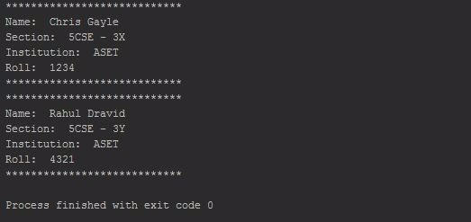

Experiment-2

Date:29/07/2018

Objective:Write a program to swap given two numbers.

Code:

def print_value(a,b):

print("a : ", a)

print("b : ", b)

def swap1(a, b):

temp = a

a = b

b = temp

print_value(a, b)

def swap2(a, b):

a = a + b

b = abs(a - b)

a = abs(a - b)

print_value(a, b)

def swap3(a, b):

a, b = b, a

print_value(a, b)

a = 10

b = 20

print("Printing the values before swapping. ")

print_value(a, b)

print("Swapping the values using a third variable.")

swap1(a,b)

print("Swapping the values without using a third variable. Way

- 1. ")

swap2(a,b)

print("Swapping the values without using a third variable. Way - 2.")

swap3(a, b)

Output:

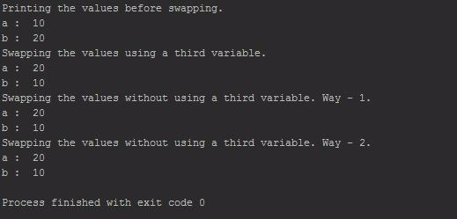

Experiment-3

Date:29/07/2018

Objective:Write a program to find whether a number is prime or not.

Code:

def is_prime(num):

print(num, end=" ")

if num <= 1:

return False

else:

for i in range(2, (num/2)+1):

if num % i == 0:

return False

return True

n = 5

print('Is A Prime Number.' if is_prime(n) else 'Is Not A Prime Number.')

n = 10

print('Is A Prime Number.' if is_prime(n) else 'Is Not A Prime Number.')

n = 23

print('Is A Prime Number.' if is_prime(n) else 'Is Not A Prime Number.')

Output:

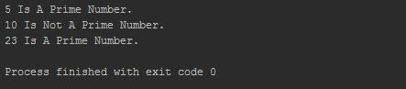

Experiment-4

Date:29/07/2018

Objective:Write a program to implement all loops

Code:

import random

symbols = ["*", "!", "@", "&", "$"]

def pattern(num):

c1 =0

c2 = 1

while True:  # Implementing the functionality of Do -While Loop

if c1 == num:

return

while c2 <= num - c1:  # While Loop

print(" ", end="")

c2 += 1

for i in range(1, 2 * (c1+2)-2):  # For Loop

print(symbols[random.randint(0, 4)], end="")

print()

c2 = 1

c1 += 1

pattern(13)

Output:

